**ASSIGNMENT 5.6**

**PROBLEM STATEMENT :**

**Write a map reduce program to use Sequence file as input and save the output in key value output format.**

**STEP 1:**

The below is the required mapreduce program for the given problem statement in the java environment.

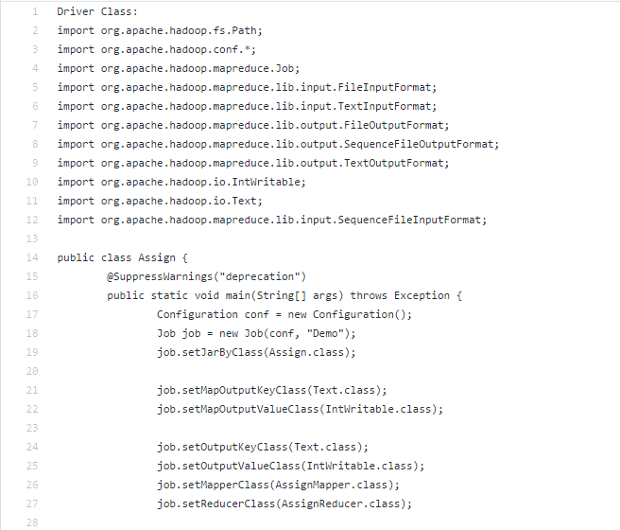

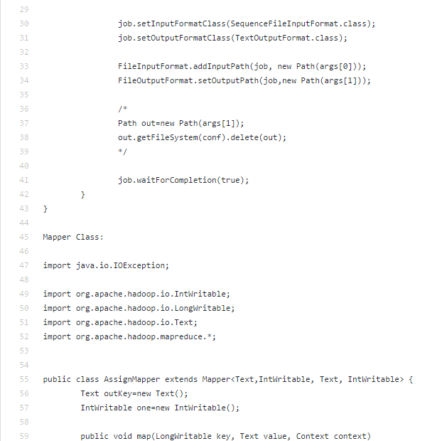

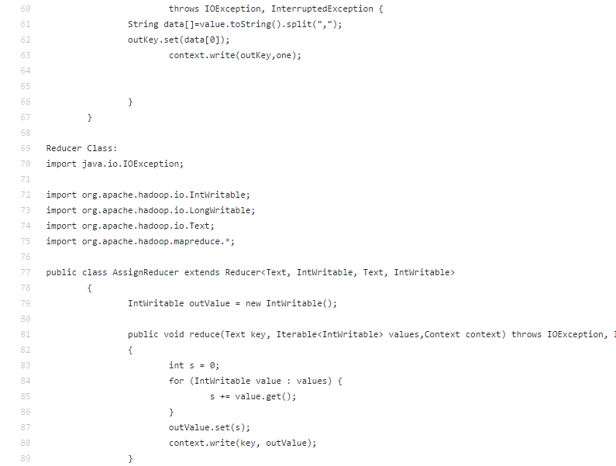



**STEP 2:**

**EXECUTION PROCESS**

The execution process for the above program in hadoop environment is shown below.

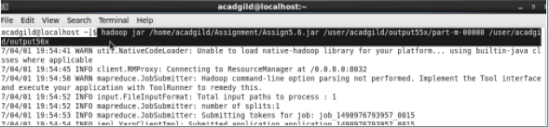

**STEP 3:**

**OUTPUT**

The output of the given problem statement is shown in the below screen shot.

